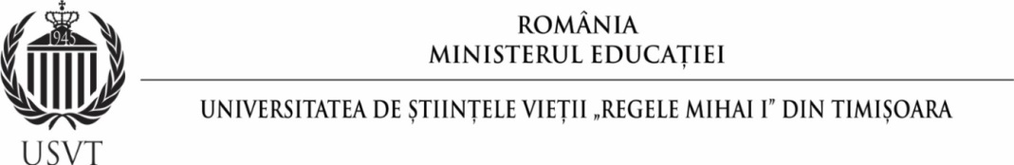

UNIVERSITY OF LIFE SCIENCES "KING MIHAI I" FROM TIMISOARA
FACULTY OF MANAGEMENT AND RURAL TOURISM
DOMAIN OF STUDY: ENGINEERING AND MANAGEMENT

Academic year 2023/2024, Ist Semester
No. | Course title | Code | ECTS
1. | Management Basics | IMIT.01.D.03 | 4
2. | Tourism Basics | IMIT.02.D.03 | 5
3. | Sport | IMIT.06.C.03 | 1
4. | Quality Management | IMIT.01.D.05 | 4
5. | Culinary Techniques and Pastry Products | IMIT.04.D.05 | 4
6. | Ecotourism and Rural Tourism | IMIT.16.D.05 | 3
7. | E-marketing in the Tourism Industry | IMIT.01.S.07 | 4
8. | Tourism Products | IMIT.15.S.07 | 4
TOTAL |  |  | 30

Academic year 2023/2024, IInd Semester
No. | Course title | Code | ECTS
1. | Computer-Aided Graphics | IMIT.13.F.02 | 5
2. | Sport | IMIT.07.C.04 | 1
3. | Financial Management | IMIT.08.D.04 | 5
4. | Human Resources Management | IMIT.09.D.04 | 4
5. | Tourism Marketing | IMIT.09.S.06 | 4
6. | Communication | IMIT.12.C.06 | 3
7. | Tourism Operations Technique | IMIT.11.S.06 | 4
8. | Strategic Management in Tourism | IMIT.06.S.08 | 4
TOTAL |  |  | 30

UNIVERSITY OF LIFE SCIENCES "KING MIHAI I" FROM TIMISOARA
FACULTY OF MANAGEMENT AND RURAL TOURISM
DOMAIN OF STUDY: ENGINEERING AND MANAGEMENT IN AGRICULTURE AND RURAL DEVELOPMENT

Academic year 2023/2024, Ist Semester
No. | Course title | Code | ECTS
1. | Management Basics | IMAA.04.F.03 | 5
2. | Modern Languages (English) | IMAA.05.C.03 | 2
3. | Food Security | IMAA.13.S.03 | 4
4. | Agricultural Marketing | IMAA.01.S.05 | 5
5. | Financial Management | IMAA.04.D.05 | 5
6. | Human Resource Management | IMAA.02.D.07 | 5
7. | Financial-Economic Analysis | IMAA.03.D.07 | 5
TOTAL |  |  | 31

Academic year 2023/2024, IInd Semester
No. | Course title | Code | ECTS
1. | Computer-Aided Graphics | IMAA.09.F.02 | 4
2. | Communication | IMAA.07.C.04 | 4
3. | Marketing Basics | IMAA.11.F.04 | 4
4. | Agricultural Business Management | IMAA.06.S.06 | 5
5. | Research Management | IMAA.08.S.06 | 4
6. | Modern Languages (English) | IMAA.18.C.08 | 2
7. | Agricultural Economics | IMAPA.09.S.04 | 4
8. | Quality Management | IMAPA.08.D.08 | 4
TOTAL |  |  | 31

